Megan Jones
Critical Seminar
Spring 2014
Stephanie Plunkett & Joyce Schiller

Illustrating in Three Dimensions

Introduction
When one first thinks about what makes a piece of art an illustration, in the sense of construction, the parameters are almost always interpreted simply. Be they realistically rendered paintings and drawings, whimsically drafted, brightly colored characters, or sketchy concept development, it is almost unanimously seen as being created as a flat work. Why does the definition of illustration limit itself to two dimensions? When we consider the basic qualities that define what an illustration is, we often discuss narrative means of communication. The act of story telling, sharing of traditions and mythologies, has often been explored in both two and three dimensions throughout history. Since the time of the cave painters, there have been sculptors working alongside, creating bison from raw clay, shamanistic lion-headed figurines, and fertility idols. These, just as much as the paintings on the walls, served an intrinsic purpose. Anthropologist Ellen Dissanayake believes that humanity has a biological need to create art, and that by doing so, we seek to make the ordinary “special”. Primordial civilizations learned through using pictograms as a way to tell a story. These early illustrators created a tradition of elevating the subject at hand by using pictures and sculptures as a means of conveying messages. As cultures developed, stories and characters have been both painted and sculpted time and time again, preserving them for future generations. Until very recently, artistic curricula involved learning to sculpt the subject at hand, so that one could understand the underlying structure, and achieve a more accurate final piece. In the modern day, visual training has become so specialized, that most illustrators have little to no sculptural training, yet are expected to use more tools than any other artistic profession to find a means of graphic communication. It is fascinating to see when an artist uses needlework, something common a generation ago, and is applauded for using a now novel approach. Those artists who are in-tuned to the challenges that lie ahead in this very diverse, multi-media field, are often those with the widest background of training or the most dynamic experimentation. This exhibition seeks to highlight artists currently exploring the use of dimensional and “non-traditional” materials, while appreciating the cultures of the past whose sculptural works influence us to this day.

Scratching the Surface

Though there have been paintings on walls since time inumerable, the sculptures are often forgotten, spare the western classics. From the Venus of Willendorf, to Moche stirrup vessels, to Greek amphora vases, there has always been traditions that involve creating work in three dimensions. When a society has developed enough for the decorative arts, some of the first pieces to be elevated by special surfaces and patterns were often functional, such as pots, ewers, and platters, or served a purpose within the society. This section serves as a reminder of where and when illustrative sculpture began, while highlighting different areas of the world that used this principle in their personal spheres. The use of sculpture in story telling is efficient for ceremonies in particular, masks often told stories of transformation while vases and and bowls showed us heroic performances. Even the everyday details, such as netsuke beads from Japan, often depicted legends while still serving their intended purpose.

Traditional Methods, Modern Times

As we return to modern times, the use of ceremonial bowls and sculptures has been diminished to near non existence. Due to the commercialization of illustration, the costs often involved, and the speed necessary for today's clinetele, sculptural work has often been pushed to the shadows. In what we now consider the illustration field, very few artists are using sculpture in their practice, and if so, it is more for play and a distraction from the daily grind. On the other side of the art world, artists who are working within what some consider the ceramic “craft” realm, have begun exploring surface details and sculptural characters that are often visually exciting, and commercially viable. With time and integration, these two fields have the opportunity to collaborate on creating a new subcategory for where illustration can be applicable in the future.

Applications of Today and Tomorrow

In this very diverse world we live in, there are many different avenues to explore for not only illustration but also sculpture, and it's not just high art and garden sculptures. Companies like Pixar are exploring 3d scanning technology with character sculpts, and children's books and full length animations can be done using sculpted characters photographed in scenes. Companies are popping up that specialize in custom, high end vinyl toys that aren't meant for play but display. The future is bright for illustrative sculpture, and the opportunities are endless. Those who are exploring the avenues are opening new pathways for future generations to express themselves in as many different media as possible. The only limitation that defines illustration moving forward should be whether or not the character or scene tells a story. Time will tell if these stories bears repeating, such as those of our ancestors.

Labels: Historical Inspiration
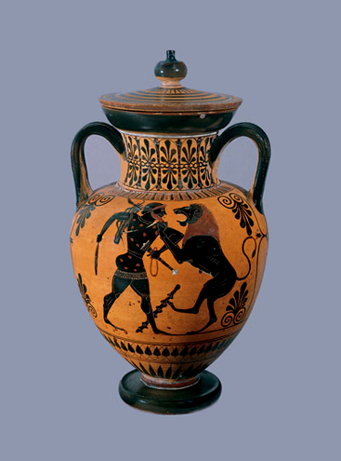
Attributed to Antimenes Painter.
Black Figure Neck-Amphora and Lid, depicting Heracles and the Nemean Lion 525 BCE
Ceramic
Phoenix Ancient Art Gallery, New York City

Throughout history, artists have attempted to depict the stories that are passed down from generation to generation in a way that is culturally relevant and lasting. One way that imagery can be more lasting is if it is incoporated with objects that are used in special rites or rituals, or even daily use. The mythologies of the Greek cultures have classically been one of the most profoundly influential even to this day. Some of this may thanks in part to the imagery painted onto amphoras and kraters, sometimes showing scenes of daily life, while others scenes from heroic tales such as the tale of Heracles or Achilles. In this scene, Heracles fights the Nemean lion, which he later skins and wraps around his form; the quintessential image of triumphant Heracles.

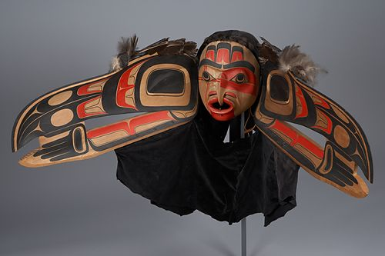
Jim Hart
Raven Transformation Mask 1985
Wood, Fabric, Paints.
University of British Columbia Museum of Anthropology

Some classic traditions endure so strongly, that artists are still working to this day in the style of their ancestors. The Native American Tribes of the Northwest Coast, with their strong oral history, also have a dynamic artistic history. Through seasonal performances of stories of caution and warning, the tribe stays tight even in the worst of times. The transformation masks are just a small part of the theatricality involved in the rituals of these tribes. Some masks tell creation myths while others warn against cannibilism in dire situations. Artists such as Jim Hart seek to keep these stories and traditions alive through their methods that mimic and enrich those of the generations before.

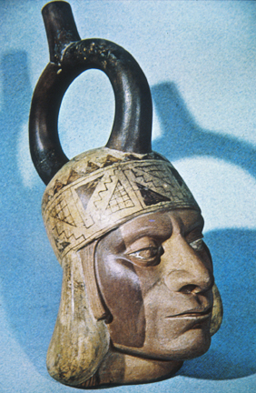
Unknown Artist (Ancient Moche)
Stirrup vessel (Portrait) 200-800 CE
Ceramic
Private Collection

One of the most intriguing cultures in history, the Moche people of Peru lead rich visually stimulating lives up until the collapse of their culture around 750 CE. The artisans of this area were skilled in sculpting portraiture, animals, and even scenes of sex, child birth, etc. What makes these unique is their incorporation into utilitarian objects of daily use such as water jugs, and containers. Each region had it's own palette of colors they preferred, but what is consistent is the striking complexity and craftsmanship that is apparent throughout the culture. This agricultural based society, who flourished for hundreds of years, are believed to have collapsed due to extreme years of flood and drought, which depleted their stores to the point of in fighting.

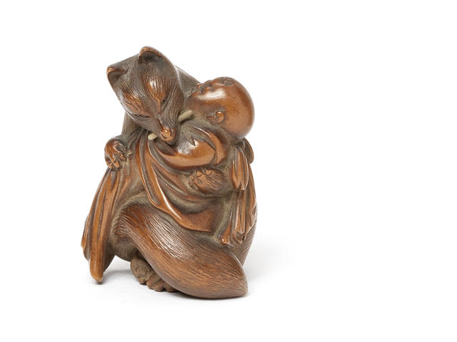
Masakazu Nagoya
Untitled Netsuke (Fox Mother and Child) 19th century.
Wood and Ivory
Bonhams Auction, UK

Many cultures have mythologies that involve animals and their interactions with humanity. Foxes around the world are seen as tricksters and often manipulative, but what happens when the fox falls in love with a man? This netsuke bead depicts an urban legend in which a kitsune falls in love and births a child with a well known artist. In the end, she must return to the forest, and she is seen holding her child one last time before returning to her own world.

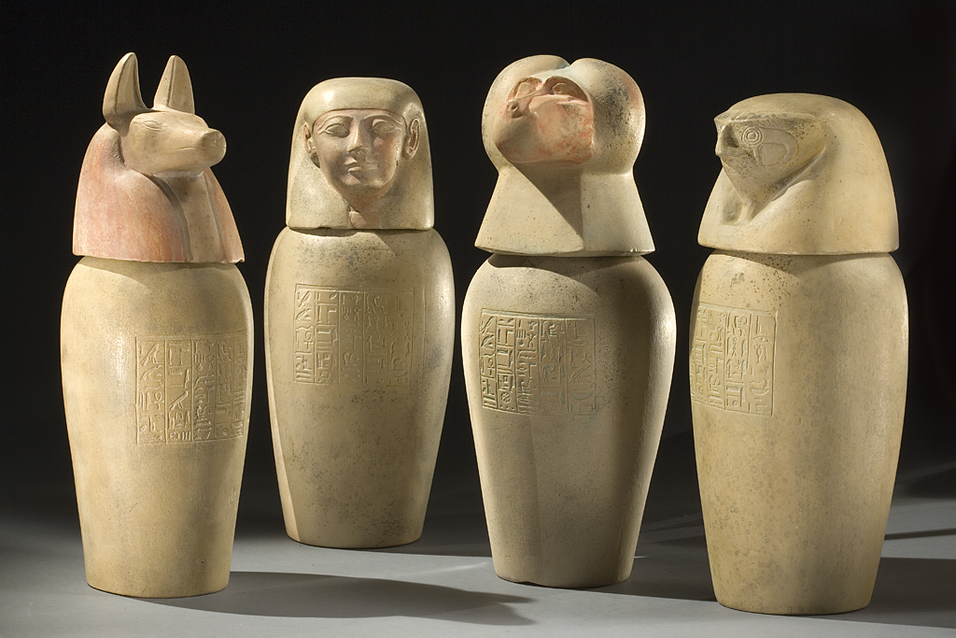
Unknown Artist (Ancient Egyptian).
Canopic Jars. Approx. 2500-1600 BCE.
Stone.
Smithsoniam Institute, Museum of Natural History, Department of Anthropology

Like the Moche people, the much more well known Egyptians often decorated the objects of their lives, including those dedicated for after life. Canopic Jars of the later dynasties had the heads of the sons of Horus, minor gods involved in the intricate process of meeting the qualifications set by Osiris allowing their souls to enter the world of the dead. Each of these gods guarded the organs enclosed to ensure that the deceased is complete on the other side. Often carved from stone or built of ceramic, many canopic jars have survived to this day, living eternally in museums around the world.

Traditional Methods, Modern Times

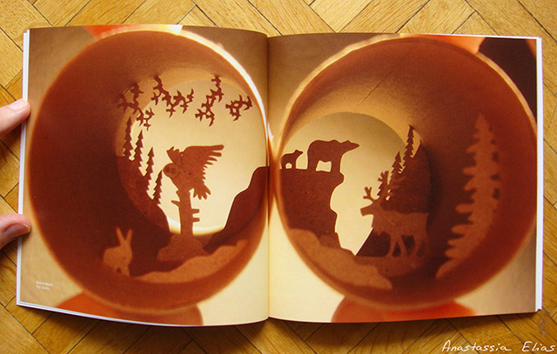
Anastassia Elias
Untitled from Rouleaux Series 2013
Toilet Paper Roll
Collection of the artist

For hundreds of years, artisans have cut paper into silhoutted characters and scenes, varying from heroic tales such as those of Heracles, to lords and ladies courting. Cut paper art in recent years is seeing a resurgence of popularity because of it's graphic qualities, along with the cheapness of material. Artist Anastassia Elias takes this thriftiness to the next level with her Rouleaux series, being completely made of toilet paper rolls. These intimate pieces invite the viewer to explore tiny crevaces to discover miniature worlds that vary from nature, to industry, to the imagination.

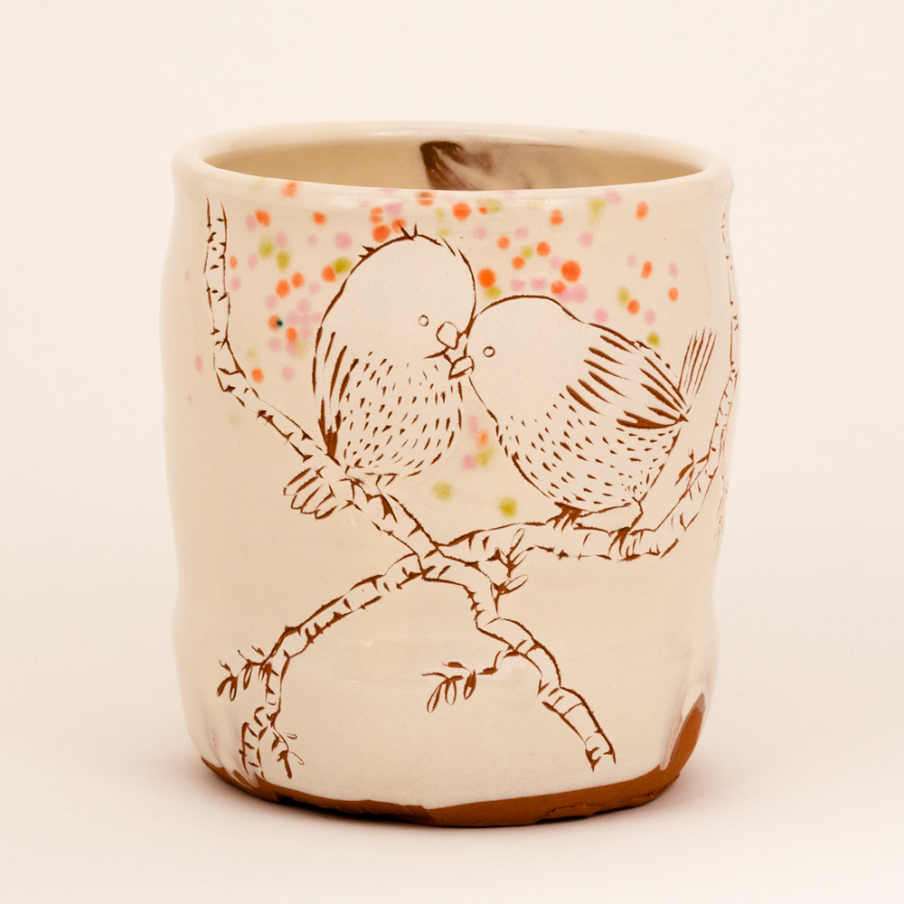
Ayumi Horie
Love Birds on Crossing Branches Cup 2014
Ceramic
Private Collection

Ceramics has often had decorated surfaces, thanks to techniques such as decals, lusters, and china paints. None have as much whimsy and playfulness as those of contemporary artist Ayumi Horie. Bridging the gap between the world of craft to that of illustration, Ayumi has taken advantage of the possibilities the internet offers in expanding her viewership and created playful marketing campaigns to advertise her personal and collaborative work. Her unique method of carving out on the throwing wheel, along with slip surfaces carved with simplistic animals sets her work apart from a growingly complex ceramic market.

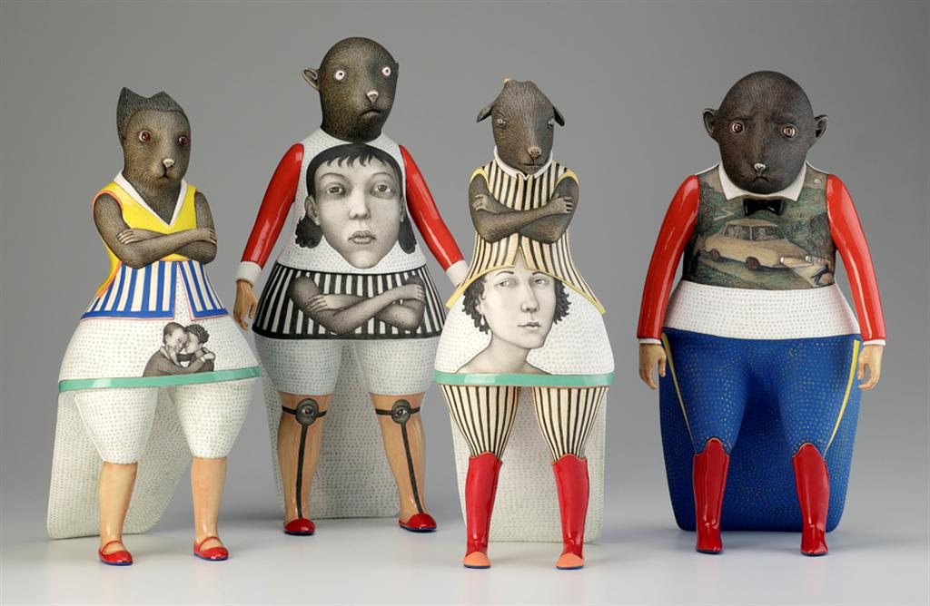
Sergei Isupov
Humanimals Group 2011
Porcelain, Glaze, Slip
Collection of the artist

Blurring the line between not only high art, low art where illustration is forced to, and the craft world that ceramics often is denegraded to, the work of Sergei Isupov often builds forms that hard difficult to distinguish the media and construction. Intricately painted glazes decorate every surface, even those that cannot be seen when displayed properly, such as the bottom. Sergei Isupov sees himself not as a ceramicist, but an existential artist of the universe whose canvas happens to be in three dimensions. His work resides in museums and private collections, but has the ability to speak in such a way that it could serve as an accompanying illustration.
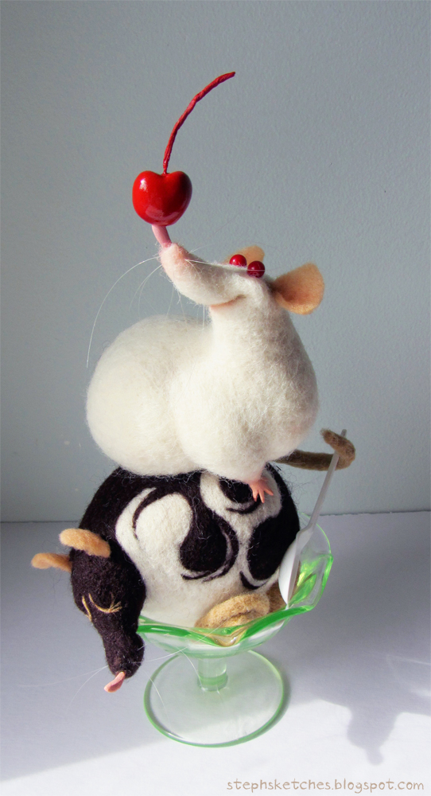
Stephanie Laberis
Raturdae
Needlefelt
Private Collection

While modern teaching practices tend to push young artists through schooling as quickly as possible, limiting their exploration to minimal media, some artists take the time to play and learn techniques that have no use in their main occupation. Stephanie Laberis, whose charming digital illustrations have been used in development of television series and video games, has dedicated time to learn a very non-linear art form; needlefelting. Recreating her illustrations in three dimensions, her animals maintain the charm and sophistication that is evident in her flat work. This medium is not an easy alternative by any means, but it is an opportunity to enrich her digital practice and help her maintain a steady art making flow.

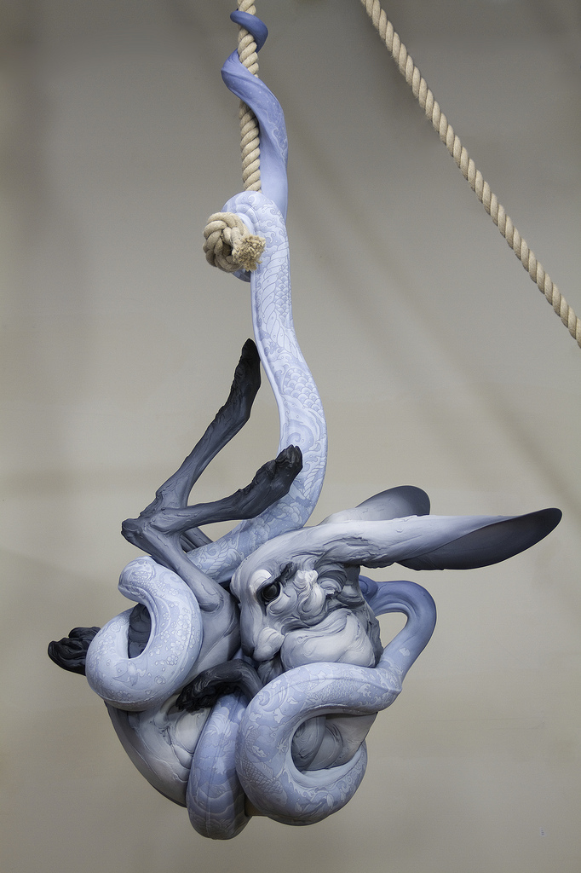
Beth Cavener Stichter & Alessandro Gallo
Tangled Up in You
Ceramic, Household Paints
Private Collection

When Beth Cavener Stichter, one of the highest paid contemporary ceramic artists joins forces with fellow artist Alessandro Gallo for a collaboration, beauty is guaranteed to follow. Tangled Up in You defies gravity in a way that ceramic very rarely attempts, dangling a large feminine rabbit entwined in the body of a serpent which is grasping onto length of rope attached to the ceiling. This challenging yet subtle piece's sophisticated surface is hand painted with tattoos shifting along the body of the snake. It is diffcult to tell whether the bite is one of love or hunger.

Applications of Today and Tomorrow

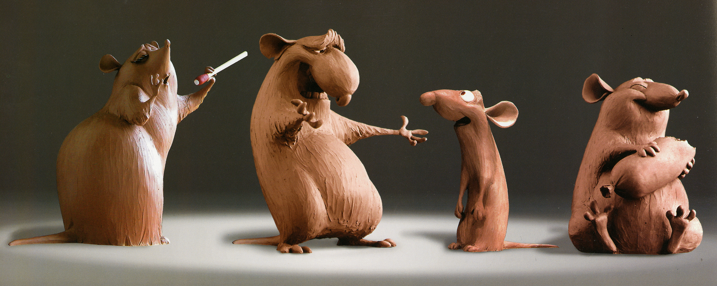
Greg Dykstra
Untitled Development for Ratattouille 2002
Oil Clay
Pixar Studios

In this age where technology is developing at such an incredible pace, it is interesting to see a sculptor working for an animation studio. Greg Dykstra, among others, takes the development art of other artists and creates complex 3 dimensional maquettes for the animators to use as reference. Not twenty years ago, this meant that a 2d animator would draw from the maquette as it sat idly on their desk, but thanks to new technology created by Pixar, technicians can scan the sculptures directly into 3d animation programs to manipulate. While the cel shading, hand drawn processes have faded into obscurity, sculpture for animation is continuing to thrive in many studios.

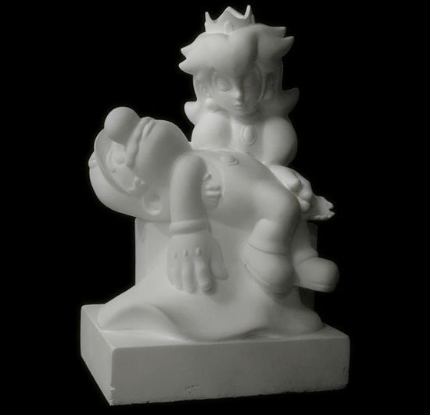
Kordian Lewandowski
Pieta (Game Over) 2008
Insulation Foam

What happens when fan art of classic video game characters collides with the classical history of fine art? Kordian Lewandowski's Pieta mimics Michelangelo's original piece, depicting Mary cradling the form of Jesus after the crucificition. Lewandowski's version references the Mario series, with Princess Peach cradling the dead form of Mario. Sculpted out of foam, the surface is mystical and difficult to distinguish. With sanding and smoothing, Lewandowski has taken an everyday material and created a new classically defining work.

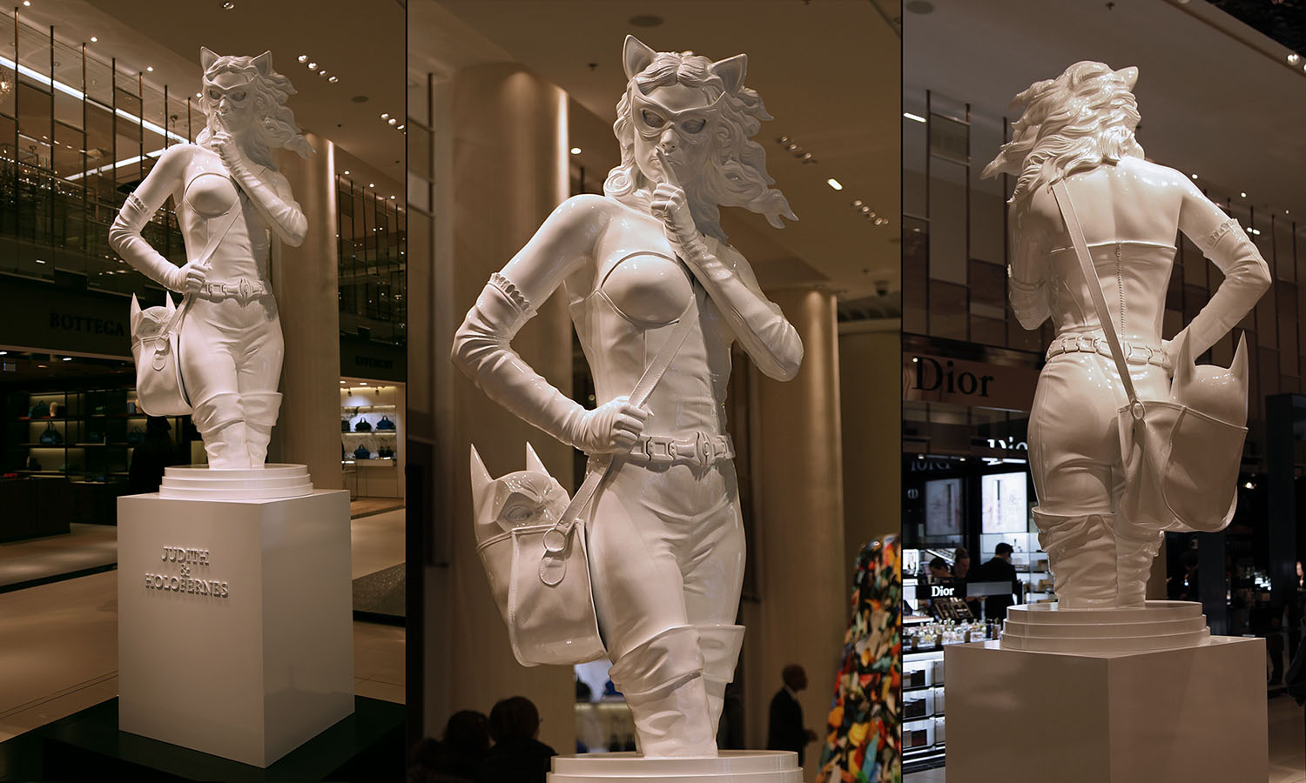
Kordian Lewandowski
Judith and Holofernes 2013
Polyurethane, Automotive Paint and Varnish

Again referencing classical art history, Lewandowski looks to Judith and the decapitated head of Holofernes, replacing these famous icons with more modern, recognizable faces. Judith is played by Selena Kyle aka Catwoman, while the head of Batman is tucked into her bag. She raises her finger to ensure the viewer keeps quiet, playing upon the secretive nature of the many versions that had come before, such as those of Carravaggio and Gentileschi. Built from modern materials, the surface mimics that of marble, forcing the viewer to investigate what period it is from.

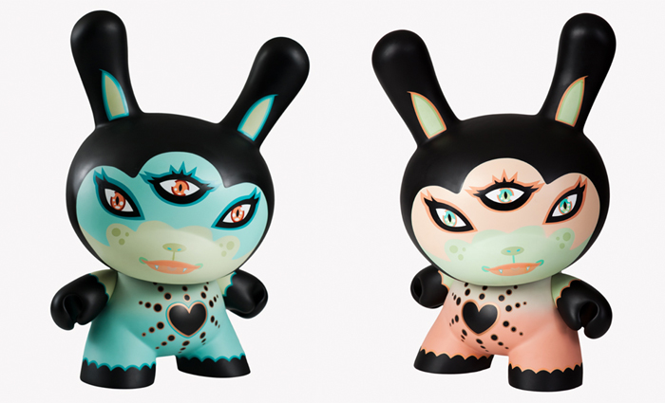
Tara McPherson
Black Heart of Gold Dunny 2012
Limited Edition Vinyl Toy

In recent years, toys have become more than just for play. Companies have begun to cater to the adult collector of high end vinyl sculptures and toys. Kid Robot, one of the largest toy design companies in the market often collaborates with popular artist to design surfaces for their generalized blanks called Dunnys. Tara McPherson has had a rich history with this company, creating her own line of toys based off of her poster designs. The Black Heart of Gold Dunny is the most recent collaboration between the artist and company, produced after her original paintings, in a limited edition of 100.

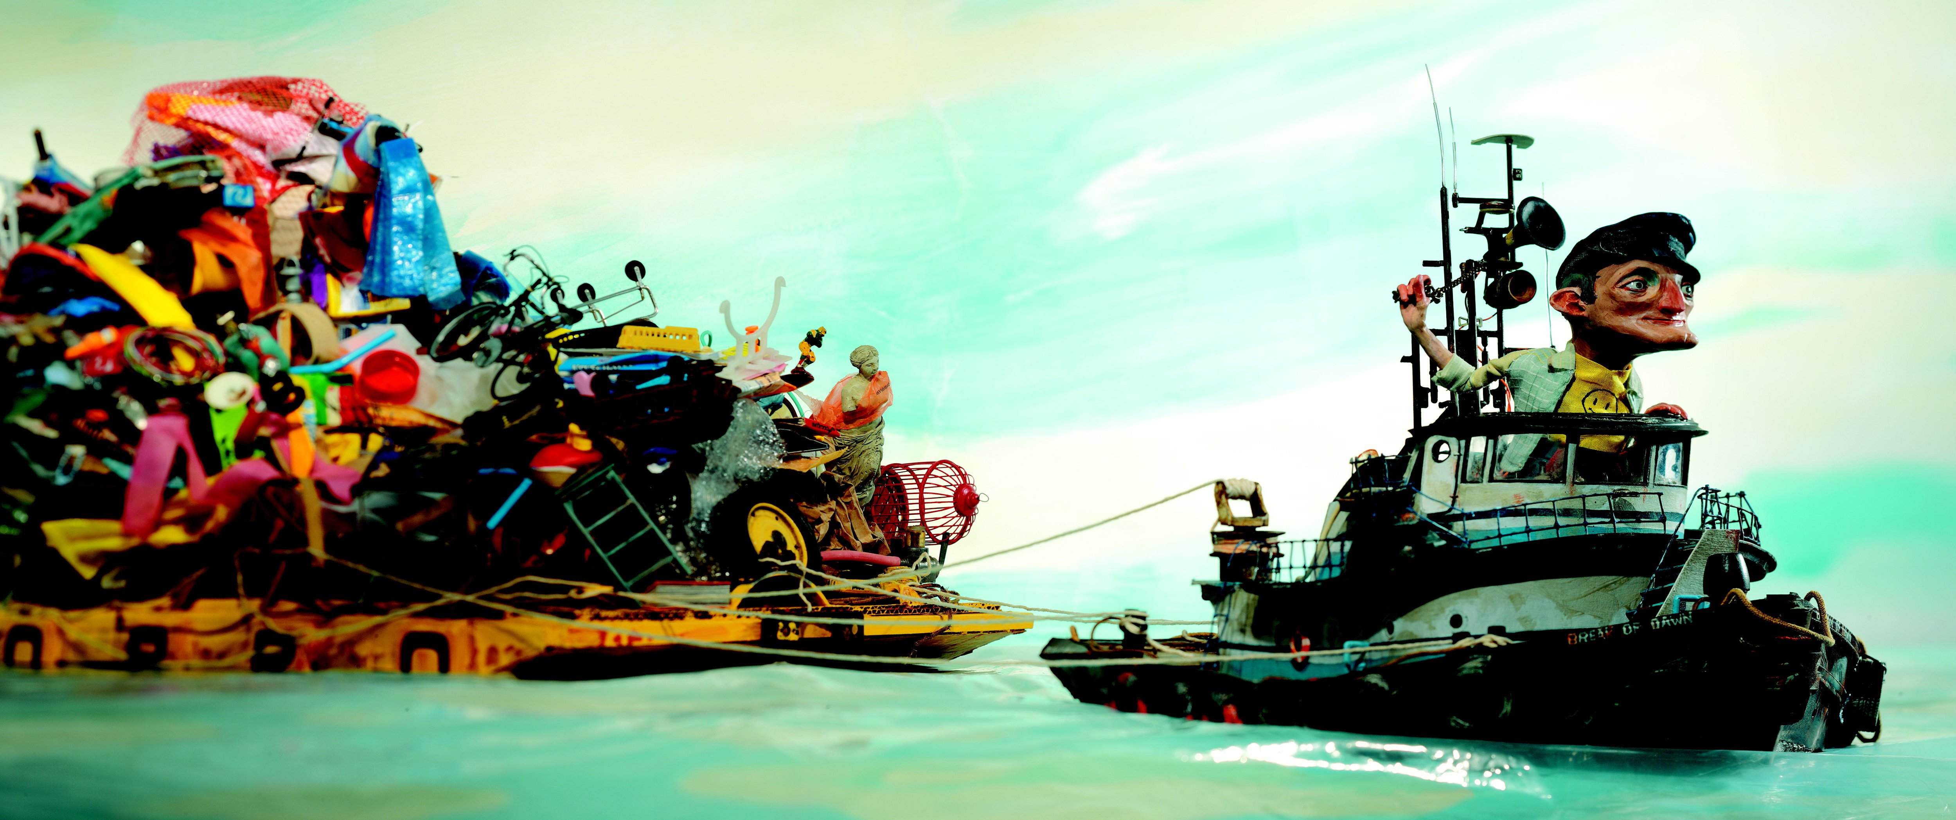
Red Nose Studios
Sculpt from Here Comes the Garbage Barge 2009
Polymer clay, Found Objects

When one thinks of sculptural illustration, our minds more often than not imagine the work of Red Nose Studios. Masterfully sculpt, lit, and photographed, these pieces are constantly challenging the boundaries of what illustration can and cannot be. This piece, from their picture book Here Comes the Garbage Barge, includes the usual sculpy figure along with found objects such as toy miniatures, wire and banana peels. These pieces add a sense of realism and scale to the book, slowly “decaying” on Captain Duffy's tugboat journey for a safe harbor in which to drop his very disgusting load.

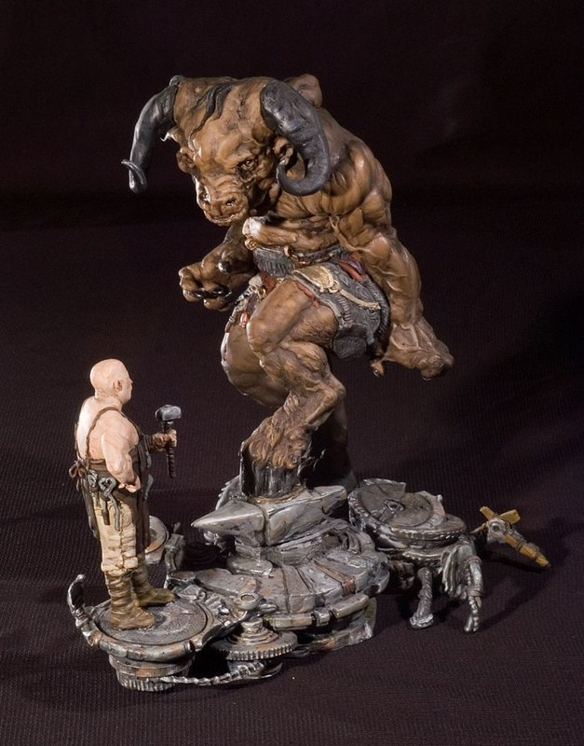
Brandon & Jarrod Shiftlett
Noynub: Deal with the Devil 2007
Paintable Resin Kit

Most toys are presented assembled and painted, ensuring that there are no choking hazards for the children they are intended for. Figurines such as the work of the The Shiftlett brothers is in no way suited for the juvenile market thanks to their design, construction and themes. Companies such as Games Workshops in the UK have developed table top games using customizable miniatures made of molded plastic, allowing the player to have endless options for making their characters unique. The Shiftlett Brothers are within this fantasy realm, where individuals purchase with the intent to customize their figure however they please. This niche within the artist toy market plays an intermediary between concept design such as that of Greg Dykstra and also the work of Tara McPherson and Kid Robot, meshing detailed rendering with commercialized processes.

