JiyeonPak
Critical Seminar
Apr.19.2014

Let’s go to meet our friends!
The friendship between humans and animals has been one of the important themes of picture books, which describe the innocence of childhood. As a friend that we need to take care of, a friend that we get comforted from, and a friend that enjoys adventures together, animals have been depicted as our loyal companions. However, in some parts of our world, people consider animals as things that we can use for our profit. Moreover, used as commodities, they occasionally are atrociously abused by humans. A large number of animals spend their whole lifetime in small cages raised solely as food, animals are often killed cruelly for all sorts of fashion items. Also, some people don't have a sense of responsibility to their own pets, they do not treat them well or even abandon them. Animals that live in zoos or work for shows are denied their freedom for people's amusement. Most of us are callous to their agony and often justify our guilt because we are not the ones who physically harm them. But they are suffering from us, and we don't have any rights to treat them in a violent way. This exhibition will be a good chance to remind ourselves of the value of life and share the message that animals are our friends, and we should live together peacefully. The main target will be children, but it will also provide a great opportunity for adults to return to the innocence of childhood. The illustrators from different countries such as Japan, Australia, Taiwan, the United Kingdom, South Korea and the United States are participate in this exhibition which shows that the friendship between humans and animals is a global notion around the world. Moreover, it will be a great exhibition to share diverse picture books that are based on various cultures. Audiences could experience varied art styles from oriental paintings to digital photographs. That will help to show the beauty of picture book illustrations which often are devalued when compared to stories of picture books and fine art. The exhibition is focused on cotemporary illustrators and picture books that are easy to obtain. At this exhibition, audiences will experience the original illustrations that they usually see in picture books at home and in libraries.
They are there for us all the time!
They're always there for us. They keep us company all the time. Better than any words, they comfort and help us with big sincerity. By visiting a sick friend or giving a ride on their backs, they show their friendship. Remember their love for us. And be thankful for their honesty and pure heart.
In this section, there are illustrations of picture books A Sick Day for Amos McGee, The Gorilla, Zen Short, Gus, the dinosaur bus and Who wants a cheap rhinoceros?. A Sick Day for Amos McGee was the winner of the 2011 Caldecott Medal. This book is a story about the several animals that are taking care of sick Mr. McGee. The Gorilla is a picture book by British illustrator Anthony Browne who is a classic picture book author and illustrator as well as a Hans Christian Andersen Award-winner. The book is about a gorilla that is floating in the sky with a lonely girl to the zoo. Zen series created by Jon J Muth, who is famous for water color painting technique, is about the panda Zen that is helping and playing with Addy, Michael, and Karl. Zen Shorts was also chosen as a honor book by Caldecott in 2006. Gus, the dinosaur bus is a story about a huge dinosaur that helps children to go to school. This book was illustrated by Bei Lynn who is an award-winning artist who has illustrated around 20 picture books for children.
Who wants a cheap rhinoceros? was wrote and illustrated by Shel Silverstein who also was a famous American- poet, singer-songwriter, cartoonist, screenwriter. The giving tree accounts among as his major work.
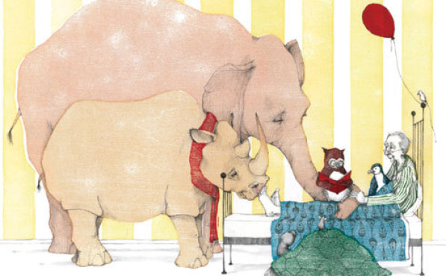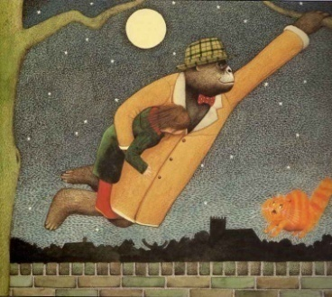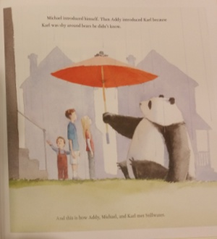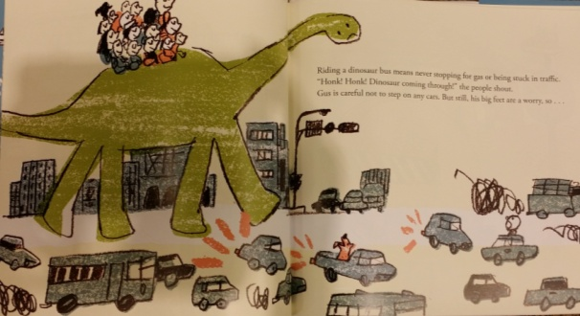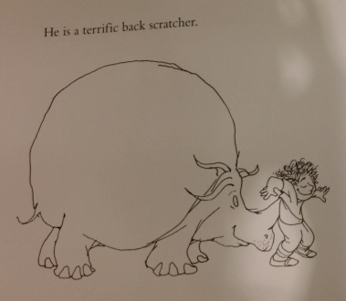
We often help them!
We often take care of animal friends! Taking care is sharing love, as in sharing love we become more warm and hospitable. Communicating and helping is not difficult. Why don't we sing a song or give a scarf to them? That will also make us happy.
In this section, there are illustrations of picture books Red muffler, The Lonesome Puppy, Make Way for Ducklings, Up & Down and The Girl Who Wouldn't Brush Her Hair.
A Korean illustrator Sang-ho Woo created Red Muffler by making small sets and taking picture of them.
It is story about a baby penguin that is suffering from global warming and the chef who is helping the penguin. The Lonesome Puppy is a picture book about a girl who is comforting a huge lonely dog by a famous Japanese pop artist Nara Yoshimoto. Make Way for Duckling won the Caldecott medal in 1941 and became a favorite of millions until now. In this book, we can meet a mother duck and ducklings that are moving to another place to live and a policeman who is helping with their move. Oliver Jeffers who is one of the most famous contemporary illustrators made a story and drew illustrations about a penguin that is longing for flying and a boy who is helping the penguin called Up and Down. In The Girl Who Wouldn't Brush Her Hair, we can meet a little interesting girl who refuses to brush her hair and provides her hair to some mice as a house. This book is written by Kate Bernheimer and illustrated by Jake Parker. 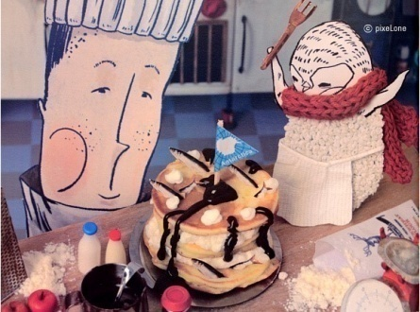 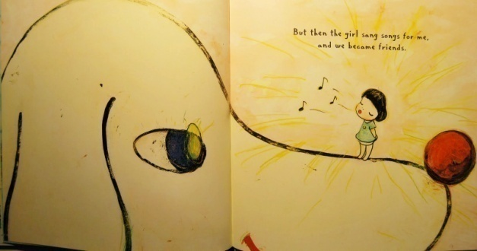
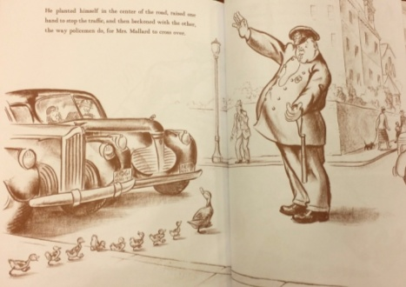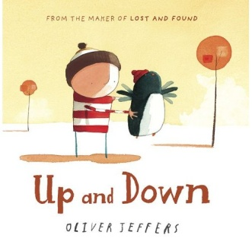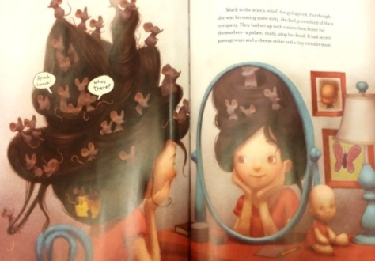
Let's play together!
Spending a great time with someone is exciting! Running around and dancing builds up our friendship with animals. If we are with valued friends, nothing is going to scare us! We can share the same feelings even though we cannot communicate through languages. Friendship will fill up our lives with beautiful memories! Why don't you make a new special friend?
In this section, there are illustrations of picture books Dream Friends, I’d know you anywhere, My love, Black dog, Miki and the wishing star and Choigomutginnal. Dream Friends that was created by Korean illustrator You Byun is a story about an adventure of a girl with her imaginative dog in her dream world. You Byun accomplished a praiseworthy debut for this book. The picture book series of Nancy Tilman is famous for the various types of friendship between diverse animals and humans. In this exhibition, we can experience an illustration of I’d know you anywhere, My love. Levi Pinfold who is a compelling young Australian illustrator made a book called Black Dog. This book depicts the relationship change between a small girl and a huge black dog that everyone is afraid of. Black Dog has been praised highly by many critics. Miki and the wishing star is a picture book from a much sought-after, renowned fine artist, Stephen Mackey. The series of Miki is about the friendship between Miki, a penguin and a polar bear in winter. A Korean illustrator Jung-Soon Ko produced a picture book called Choigomutginnal, which means the best day of my life. This book offers nostalgic illustrations about the special friendship between a grandfather and a rabbit.
